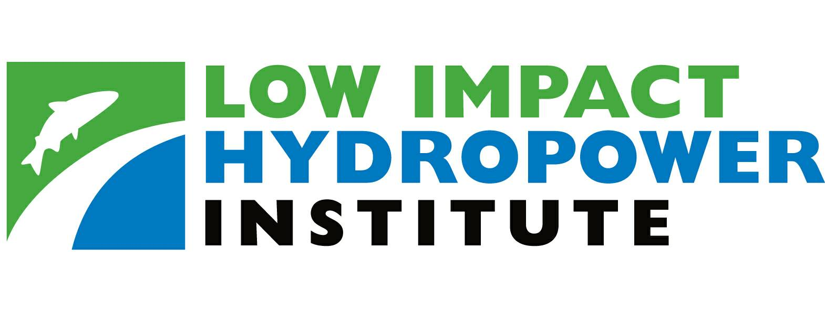

LIHI HYDROPOWER CERTIFICATION
School Street Hydroelectric Project (FERC No. 2539)

Certificate No. 000063

November 16, 2010 (effective November 20, 2009)

This is to certify that Brookfield Renewable Power’s (Applicant) School Street Hydroelectric Project (FERC No. 2539) has been determined by the Governing Board of the Low Impact Hydropower Institute to meet the requirements of the Institute’s Hydropower Certification Program. The facility is located on the Mohawk River at Cohoes Falls.

In reaching its decision to certify the School Street Hydroelectric Project, the Low Impact Hydropower Institute’s Governing Board reviewed the application for certification, as well as the Application Reviewer’s report. The Board’s vote to certify the School Street Hydroelectric Project was unanimous and included the following non-standard conditions:

(1) Brookfield be required to submit to LIHI the results of the effectiveness testing required under the license and settlement agreement at the same time as such information is being submitted to resource agencies,

(2) Any submittal include a statement from Brookfield that discusses how the effectiveness testing results demonstrate that downstream migrating fish are being safely passed, and

(3) Brookfield submit to LIHI any comments prepared by resource agencies on their review of this effectiveness testing.

LIHI will retain the right to suspend the certification or take other appropriate action should this testing and analysis thereof demonstrate that safe downstream passage is not occurring.

The LIHI Governing Board approves certification for the School Street Hydroelectric Project for five-years with project specific conditions. Any Commenter may submit within 30 days of the posting of the Certification Decision on the Institute’s Web page a letter to the Certification Administrator requesting an appeal. An appeal request must include specific reasons why the hydropower facility should have failed one or more criteria. If an individual or organization did not comment on the initial Application Package, they may not file an appeal.
The effective certification date for the School Street Hydroelectric Project is November 20, 2009 and will expire on November 20, 2014. During the time the Project is certified, you may market the School Street Hydroelectric Project facilities as LIHI certified.

The Low Impact Hydropower Institute reserves the right to take any actions it deems necessary in response to any new information or changed circumstances relevant to this certification. These actions may include modification, suspension, or revocation of this certification. The Project owners will receive notice and an opportunity to comment prior to any such actions. The general terms and conditions for use of the certification, and for compliance, are described below.

I. CERTIFICATION USE REQUIREMENTS

A. Federal Trade Commission Principles:

Any use of a LIHI certification must follow the principles established by the Federal Trade Commission in its Guides for the Use of Environmental Marketing Claims, 16 C.F.R. Part 260. Under the Federal Trade Commission principles, all environmental claims used in advertising must:

1. Be factually based (and objectively verifiable to the extent technically possible);

2. Not overstate environmental attributes or benefits, expressly or by implication;

3. Present comparative claims in a manner that makes the basis for the comparison sufficiently clear to avoid customer deception; and

4. Ensure that any necessary qualifiers or disclaimers be sufficiently clear and prominent to prevent deception.

B. Language for Describing a LIHI Certified Hydropower Facility:

The following is acceptable language for describing a certified LIHI Hydropower facility. This language must accompany all claims of LIHI Hydropower certification. This language must be clear and prominent and in close proximity to the claims of LIHI Hydropower certification. Any modifications to descriptions must be pre-approved by the Low Impact Hydropower Institute pursuant to Section E below.

This product includes Hydropower from facilities certified by the Low Impact Hydropower Institute (an independent non-profit organization) to have environmental impacts in key areas below levels the Institute considers acceptable for hydropower facilities. For more information about the certification, please see www.lowimpacthydro.org.

- Language for Referring to Supporters of the LIHI Hydropower Certification Program

As discussed above, an organization, company or individual may become a LIHI Hydropower Certification Program Supporter by endorsing the goals and objectives of the LIHI Hydropower Certification Program. Endorsement of the Certification Program’s goals and objectives or any other support of the Low Impact Hydropower Institute does not imply endorsement of individual hydropower facilities meeting the criteria or any resulting power product, nor does endorsement imply the labeling of other hydropower facilities as high impact.

Any reference to individuals, companies or organizations that are LIHI Hydropower Certification Program Supporters or that otherwise support the Low Impact Hydropower Institute, must include the disclaimer provided below. This disclaimer must be clear and prominent and in close proximity to the reference to supporting individuals, companies or organizations.

The following organizations support the goals and objectives of the Low Impact Hydropower Certification Program [or otherwise support the Low Impact Hydropower Institute (add if relevant)]. Certification of a facility by LIHI does not imply endorsement of that facility or any resulting power product by any of these organizations.

D. Language Use:

It is expected that language referring to the LIHI Certified Hydropower designation and supporters will appear only in written materials related to the certified facility or to power generated from the facility. Any use of the certification other than that consistent with these Certification Use Requirements must be pre-approved by the Low Impact Hydropower Institute pursuant to Section E below.

E. Approval of Alternative Language and Claims:

The Low Impact Hydropower Institute must pre-approve the language regarding the Low Impact Hydropower Institute or Certification Program in any press release or product marketing materials that departs from the pre-approved language for describing the LIHI Hydropower Certification Program or Supporters.

II. Compliance obligations

A. Notification of Potential Non-Compliance:

A holder of a Low Impact Hydropower certification must notify the Certification Administrator as soon as possible if at any time one or more of the following occurs: (1) A violation of the LIHI criteria; (2) A violation of the Certification Use Requirements; (3) A change in conditions relevant to the certification; or (4) The receipt of a notice of violation or non-compliance relevant to the facility’s certification from any government agency. Any other party may also notify the Certification Administrator of the occurrence of one or more of these conditions. The notification may include an explanation as to why the violation or change in conditions does not amount to a significant violation warranting penalties.

B. Review of Potential Non-Compliance:

The Application Reviewer will review the alleged violation or change in conditions, make any necessary inquiries, and, if necessary, request additional information from the certified facility. This request for additional information may include a facility inspection by the Application Reviewer. The Application Reviewer will submit a written report to the Certification Administrator regarding whether a compliance violation has occurred. Based on this report, the Certification Administrator will make a recommendation regarding compliance and penalties to the Governing Board. The Governing Board will determine what compliance action is appropriate. Standards for compliance and penalties for non-compliance are provided below.

C. Annual Statement:

A holder of a LIHI certificate must submit a statement to the Certification Administrator confirming that during the preceding year, there has been: (1) no violation of the LIHI criteria; (2) no violation of the Certification Use Requirements; (3) no change in conditions relevant to the certification; and (4) no receipt of notice of violation or non-compliance relevant to the facility’s certification from any government agency. The statement must be submitted on or about the anniversary date of the certification. LIHI’s practice is to send a compliance form to certified facility managers each year, usually around two weeks prior to the Low Impact facility’s certification anniversary. Failure to file an annual statement, or a material misrepresentation contained in the statement may result in revocation of the certification.

All certified projects that have a settlement agreement as part of their license, must file with LIHI copies of annual implementation/compliance reports required by FERC or other relevant agencies. If there are no implementation/compliance reporting requirements by FERC or other relevant agencies, LIHI would require certificate holders to develop and submit implementation/compliance reporting that met LIHI’s needs.

III. PENALTIES FOR NON-COMPLIANCE

Facilities certified by LIHI must maintain compliance with all LIHI criteria and with the Certification Use Requirements. If the Governing Board finds that a certified facility has committed a significant violation of these requirements, or if the Governing Board finds that a material misrepresentation of fact was made in any submission from an Applicant, the Governing Board shall:

A. Revoke the certification;

B. Bar the holder of the LIHI certification from re-applying for five years;

C. Require the holder of the LIHI certification to notify immediately its current customers that its certification has been revoked, and, if its customer does not deliver power to the ultimate retail customer, to notify immediately the retail marketer; and/or

D. Require any entity marketing power from the facility immediately to stop employing the LIHI certification in its marketing unless it can find other supply that is LIHI Certified Hydropower.

In unusual circumstances, the Governing Board has the authority to require additional penalties as it deems appropriate.

IV. RENEWAL OF CERTIFICATION

A. Re-Certification Application:

You may apply for renewal or re-certification by completing and submitting a Re-certification Application Package. This Re-certification Application Package will include:

1. Response to the LIHI questionnaire to determine if any material changes have occurred in the Certification terms that would affect the certification (use the most recent LIHI questionnaire which is enclosed and provide only information that has changed from the original filing). If there are material changes, provide information which responds to the relevant questions on the original certification questionnaire and supporting documentation. If there have been changes in the Low Impact Hydropower criteria, provide information regarding the new or revised questions on the original certification questionnaire and supporting documentation;

2. A sworn statement from an officer of the Applicant that the material presented in the Re-Certification Application Package is true and complete;

3. A waiver of liability signed by an officer of the Applicant stating: “The primary goal of the Low Impact Hydropower Institute’s Certification Program is public benefit. The Governing Board and its agents are not responsible for financial or other private consequences of its certification decisions. The undersigned Applicant agrees to hold the Low Impact Hydropower Institute, the Governing Board and its agents harmless for any decision rendered on this or other applications or on any other action pursuant to the Low Impact Hydropower Institute’s Certification Program.” and

- An application fee.

- Each applicant for renewal will be charged a base fee amounting to 20% of the original certification fee;

- If no material changes have occurred and the Low Impact Hydropower criteria have not been revised or if revisions have been made that do not affect the certifiability of the applicant’s project, LIHI’s Governing Board, based on recommendation from the Executive Director, will issue a Low Impact Hydropower certification and post notice of the certification on the Institute’s Web page. There will be no additional charges beyond the base renewal fee.

- If, however, material changes have occurred and/or, the Low Impact Hydropower criteria have been revised in a way that may affect the certifiability of the applicant’s project, the LIHI Executive Director will review the package and prepare recommendations to the LIHI Board in accordance with the process for the initial certification. If the LIHI Executive Director needs to hire one of the pre-qualified Application Reviewers, the Applicant will be liable for these costs which are not included in the base renewal fee.

I hereby affirm this LIHI certification of the School Street Hydroelectric Project, effective November 20, 2009

Signed,

_______________________________________________
Richard Roos-Collins
Chair, Low Impact Hydropower Institute Governing Board

_______________________________________________
Dana Hall
Secretary, Low Impact Hydropower Institute Governing Board

I hereby declare, under penalty of perjury, that the foregoing is a true and correct certificate issued by the Low Impact Hydropower Institute for the School Street Hydroelectric Project.

Dated:_________________________________________

Signed:________________________________________

Fred J. Ayer
Executive Director
Low Impact Hydropower Institute
34 Providence Street
Portland, ME 04103
(207) 773-8190

