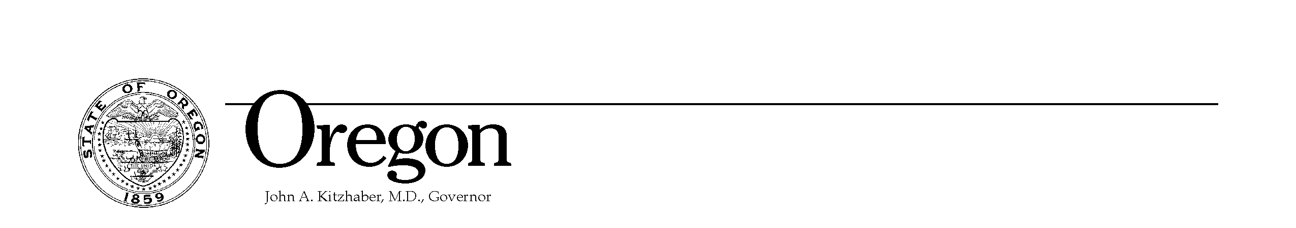
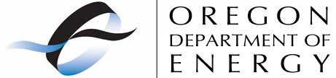
625 Marion St. NE
Salem, OR 97301-3737
Phone: (503) 378-4040
Toll Free: 1-800-221-8035
FAX: (503) 373-7806
www.Oregon.gov/ENERGY

Theodore R. Kulongoski, Governor

October 22, 2008

Fred Ayer
Low Impact Hydropower Institute
34 Providence Street
Portland, Maine 04103

Re: Low Impact Hydro Certification

Dear Mr. Ayer:

The Oregon Department of Energy (ODOE) supports certification of Northern Wasco County PUD’s hydropower facility located on the north shore of the Dalles Dam.

Northern Wasco County PUD has been very responsive to requests to operate and maintain the project to protect fish and reduce their environmental impacts. Since constructing the hydropower facility in 1990 the PUD has:

Maintained the north adult fish ladder entrance and reduced Out of Criteria occurrences since taking over.
Screens all juveniles from the auxiliary water system, providing a safer passage route than before it went in.
Contracts with biologist to monitor bypass conditions in the dewatering structure during the passage season.
A screen cleaning system that maintains minimal differential across the screens to insure safe fish dewatering and passage.

Small hydro projects like this facility can play an important role in meeting our region’s energy needs. The 2007 Oregon legislature increased the state Business Energy Tax Credit (BETC) for small hydro from 1 megawatt to 10 megawatts in size, which meet all state statutory requirements for protection of fish and wildlife. This provision will encourage facilities like the facility sponsored by Northern Wasco PUD.

The LIHI certification can help consumers in making choices that are environmentally friendly. I strongly endorse this project for your consideration.

Sincerely,
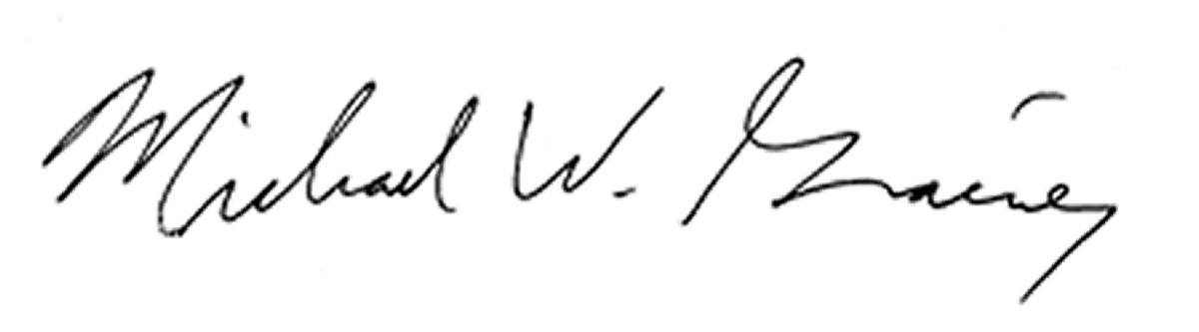
Michael W. Grainey
Director

