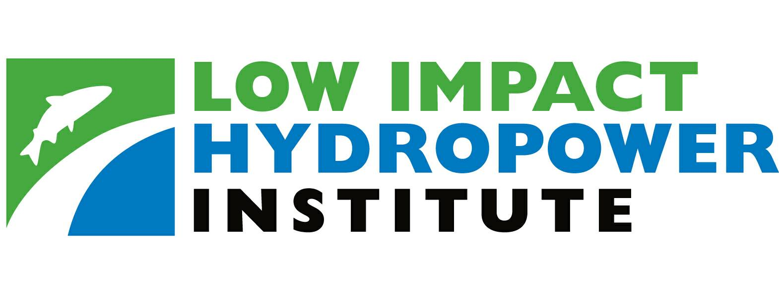
34 Providence Street
Portland, ME 04103

Tel. (207) 773-8190 • Fax (206) 984-3086
www.lowimpacthydro.org

Notice of Certification Application Filing

Penacook Hydroelectric Project (FERC No. 6689)

Portland, Maine (September25, 2009) – The Low Impact Hydropower Institute (LIHI) announced today that Briar Hydro Associates (“BrHA”) has submitted an Application for LIHI Certification for the Penacook Upper Falls hydroelectric project (“Project”). The Penacook Upper Falls Hydroelectric Project is located on the Contoocook River in the Village of Penacook, New Hampshire. The Village of Penacook is made up of a small portion of the Town of Boscawen and the northern end of the city of Concord.

Regulatory History - On December 5, 1984 the Federal Energy Regulatory Commission (“FERC”) issued a 40-year license, FERC Project 6689, to Penacook Hydro Associates (“PHA”) authorizing the construction, operation and maintenance of the project. Construction of the project began in 1984 and was completed in 1986 when the first power was generated. On January 4, 1993 the FERC authorized the transfer of the license to Briar Hydro Associates (“BrHA”).
On September 16, 1982, as part of the FERC licensing process, the New Hampshire Water Supply and Pollution Control Commission completed their review of the project and issued their finding that water quality impacts from the construction and operation of the facility would be minimal and therefore they posted no objections to the project. On May 6, 1983, the New Hampshire Water Supply and Pollution Control Commission confirmed that the project was in accordance with Sections 401(d), 301(b), 302, 303, 306, and 307 of the Federal Water Pollution Control Act.

Project Description - The project is operated as a run-of-river facility. The estimated average head is 22 feet and the project is required to maintain a continuous minimum flow of 338 cubic feet per second or the inflow to the reservoir, whichever is less. The Project consists of a timber stoplog dam with a concrete spillway that has15 gates, (6 operable steel gates, 7 fixed timber stoplog gates, and two operable (ice) gates); The Project reservoir has a surface area of 11.4 acres, a negligible storage capacity, and normal water surface elevation of 306 feet m.s.l.

The concrete powerhouse houses one horizontal shaft tube turbine with a capacity of 2,800 kW. The river banks upstream and downstream of the power house are contained by concrete retaining walls to bedrock. A tailrace is located at the draft tube exit of the powerhouse and extends downstream for approximately 350 feet. A forebay begins at the powerhouse intake and extends upstream. The project is located upstream of the Penacook Lower Falls project. The project utilizes a previously existing impoundment and the plant is unmanned, but operation is monitored on a 24/7 basis.

Public Comment

We encourage public comments on this application. Specifically, we are interested in knowing whether you think this project meets our LIHI criteria. Review the program and criteria in greater detail and then review the Project’s application. Comments that are directly tied to specific LIHI criteria (flows, water quality, fish passage, etc) will be most helpful, but all comments will be considered.

Comments may be submitted to the Institute by e-mail (preferred) at info@lowimpacthydro.org with " Penacook Hydropower Project comments" in the subject line; by fax at (206) – 984-3086; or by mail addressed to LIHI, 34 Providence Street, Portland, ME, 04103. Comments must be received at the Institute on or before 5 pm Eastern time on November 25, 2009 to be considered. All comments will be posted to the web site and the applicant will have an opportunity to respond. Any response will also be posted

For further information about the any of the projects certified as Low Impact, please contact Fred Ayer, LIHI Executive Director at (207) 773-8190, or visit the LIHI website at www.lowimpacthydro.org. LIHI is a nonprofit organization that certifies environmentally low impact hydropower facilities nationwide to help energy consumers, and to support market incentives for reducing the effects of hydropower dams on the nation’s rivers and streams.

***

