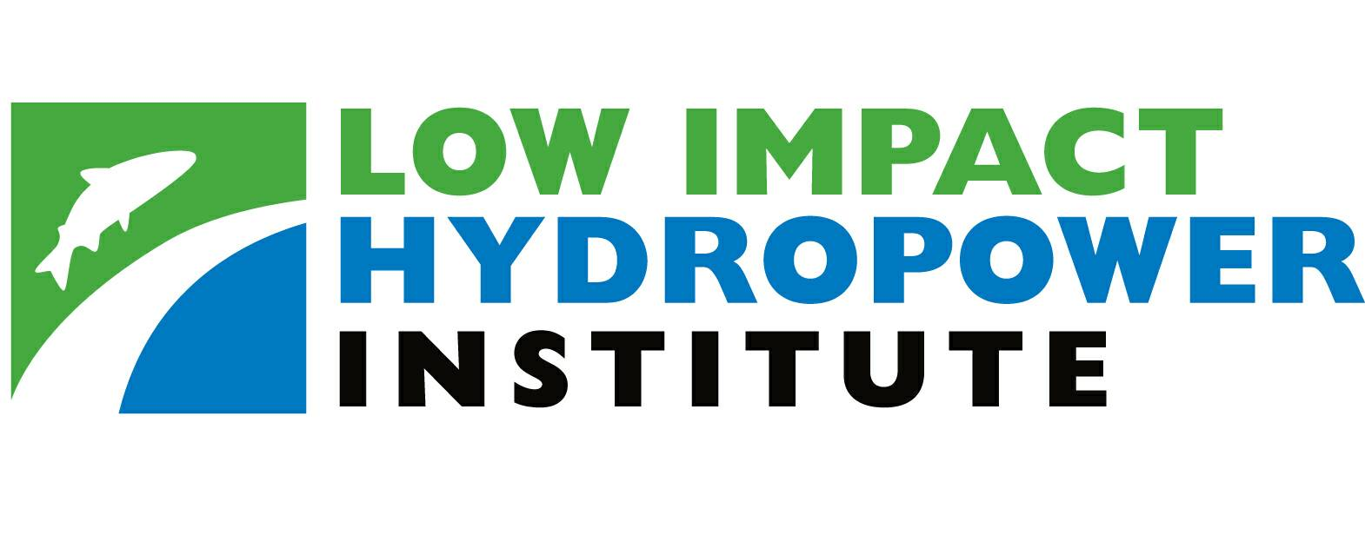

34 Providence Street

Portland, ME 04103

Tel. (207) 773-8190 • Fax (206) 984-3086

www.lowimpacthydro.org

Notice of Certification Application Filing

Ashton Project (FERC No. 2381)

Portland, Maine (December 31, 2009) – The Low Impact Hydropower Institute (LIHI) announced today that PacifiCorp Energy (“PacifiCorp” or “Applicant”) has submitted an application for certification of the Ashton Hydroelectric Project on the Henry’s Fork of the Snake River (“Henry’s Fork”) in Idaho. PacifiCorp owns two hydroelectric developments on the Henry’s Fork: Ashton and St. Anthony. Both projects are licensed by FERC as Project No. 2381. This application for Low Impact Hydropower Certification pertains to the Ashton development. The St. Anthony development is not currently operational due to an outage of the generating unit in 2003. PacifiCorp is exploring decommission or sale of the St. Anthony’s development in consultation with FERC.

The Henry’s Fork watershed in eastern Idaho and western Wyoming encompasses 1.7 million acres and over 3,000 miles of rivers, streams and canals. The river originates from the outlet of Henry’s Lake, located in the Continental Divide Mountains. The Upper Henry's Fork subbasin, located in eastern Idaho, encompasses 1,068 square miles, including 30 square miles in Wyoming and 60 square miles in Yellowstone National Park. The northern extent of the subbasin is bounded by the continental divide, which also delineates the boundary between Idaho and Montana. The subbasin is located within the Greater Yellowstone Ecosystem and possesses many of the unique geological, scenic, recreational, and wildlife attributes for which Yellowstone National Park is valued. The majority of the subbasin is managed by the U.S. Forest Service (DEQ, 1998).

The Ashton dam, located at river mile 45 of the Henry’s Fork of the Snake River (Henry’s Fork), forms the southern boundary of the Upper Henry’s Fork subbasin. After exiting the subbasin, the Henry’s Fork continues in a southwesterly direction for 79 miles through the Lower Henry’s Fork subbasin before reaching its confluence with the South Fork of the Snake River. The Ashton dam and powerhouse are situated in a sparsely populated, semi-arid area in which the dominant land uses are irrigated agriculture and outdoor recreation, particularly trout angling and hunting. The Idaho Department of Fish and Game lists the Henry’s Fork as Value Class I, the highest class possible for fishery resources. The area’s topography is flat to gently rolling, and its climate is characterized by warm, dry summers and cold, snowy winters.

The Ashton development is comprised of a 56.6-foot-high, 226-foot-long, earth and rock-filled dam that has a downstream slope covered with roller compacted concrete and an upstream slope stabilized by additional rock fill. The crest elevation of the dam is 5156.6 msl. There are two- foot-high flashboards on the dam crest to prevent spillage from reservoir wave action and an 82- foot-long reinforced concrete spillway surmounted by six 10-foot-high radial gates. The reservoir has a surface area of 404 acres, with a gross storage capacity of 9,800 acre-feet and a usable storage capacity of 3,988 acre-feet at normal water surface elevation (5156.6 feet msl). The development features a reinforced-concrete powerhouse located at the right bank, with integral intakes controlled by vertical slide gates and containing two generating units, each with a nameplate rating at 2,000 kW, and one generating unit rated at 2,850 kW.

In consultation with FERC, PacifiCorp plans to rehabilitate Ashton Dam in 2010-2011 to mitigate seepage and piping (i.e., internal erosion) risks posed by a deteriorating upstream silt core within the dam. The rehabilitation will involve excavating and reconstructing a portion of the upstream embankment. Other features of the project include replacing the headrace retaining wall, replacing the concrete crest structure, and adding a concrete overlay to an unprotected portion of rockfill between the spillway and the powerhouse (see figure 2.2-1).

Public Comments

We encourage public comments on this application. Specifically, we are interested in knowing whether you think the Ashton Hydroelectric Project meets our LIHI criteria. Review the program and criteria in greater detail and then review the Ashton Hydroelectric Project’s application. Comments that are directly tied to specific LIHI criteria (flows, water quality, fish passage, etc) will be most helpful, but all comments will be considered. Comments may be submitted to the Institute by e-mail at info@lowimpacthydro.org with " Ashton Hydroelectric Project comments" in the subject line; by fax at (206) – 984-3086; or by mail addressed to LIHI, 34 Providence Street, Portland, ME, 04103. Comments must be received at the Institute on or before 5 pm Eastern time on March 3, 2010 to be considered. All comments will be posted to the web site and the applicant will have an opportunity to respond. Any response will also be posted.

For further information about the any of the projects certified as Low Impact, please contact Fred Ayer, LIHI Executive Director at (207) 773-8190, or visit the LIHI website at www.lowimpacthydro.org. LIHI is a nonprofit organization that certifies environmentally low impact hydropower facilities nationwide to help energy consumers, and to support market incentives for reducing the effects of hydropower dams on the nation’s rivers and streams.

***

